African American Life in the 1950”s
First Impressions of life
Document A
Document B
Document C
Document D

Document E
Document F
Document G
Document H
Document I
Summarize the Rights given in each Amendment to African Americans (5 words or less)
13th Amendment:

14th Amendment:

15th Amendment:

Plessy V. Ferguson decision:

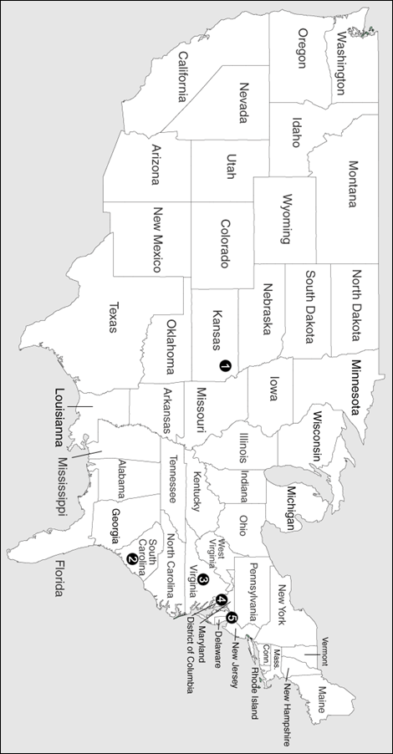
Answer Map Questions:
1.

2.

3.

4.

Brown v. Board of Education (major points of the case)
1.

2.

3.

