19.1 Soviets tighten their hold: pages 638-640.

- What was America’s View after WWII

- What was the Soviet View after WWII

- The Soviets were able to take over Albania by
- The Soviets were able to take over Bulgaria by
- The Soviets were able to take over Czechoslovakia by
- The Soviets were able to take over Hungry by
- The Soviets were able to take over Romania by
- The Soviets were able to take over East Germany by
- The Soviets were not able to take over Finland because
- The Soviets were not able to take over Yugoslavia because country.
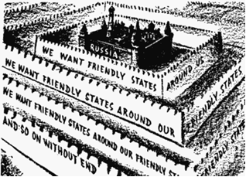
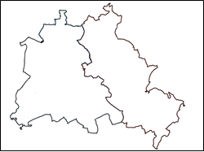
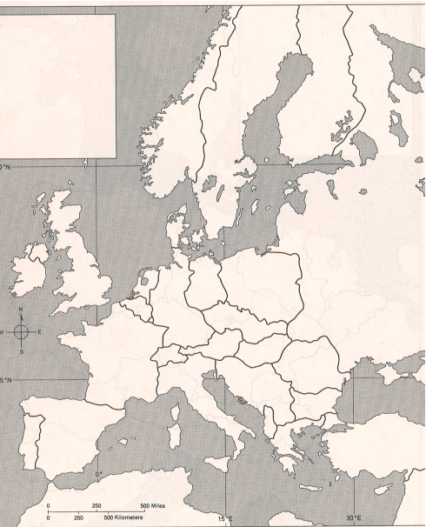
11. How does your map illustrate and the political cartoon illustrate the Soviet Union’s policy of protecting itself from its non-Communist rivals in Europe?
(Hint: think in terms of geography).

