Dwight D. Eisenhower

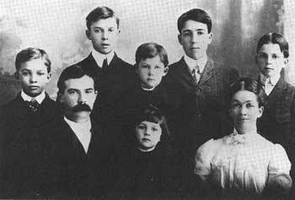
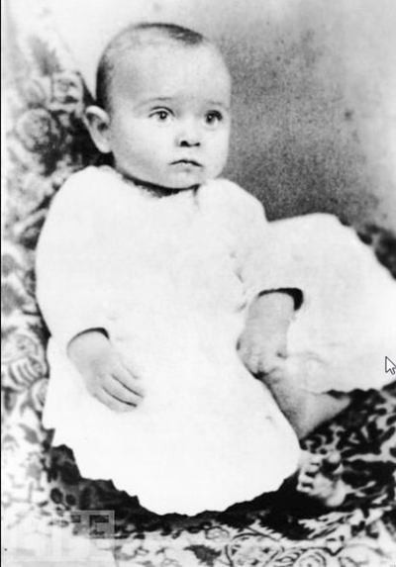
Early Life
Dwight D. Eisenhower was born on October 14, 1890, in Denison, Texas, to David Jacob Eisenhower and Ida Elizabeth Stover Eisenhower. Dwight was the third of his parents’ seven sons. The family lived in a tiny house near the railroad tracks while David cleaned train engines for a living. When Dwight was a year and a half old, his family moved back to Abilene so David could take a better job at his brother-in-law's creamery.
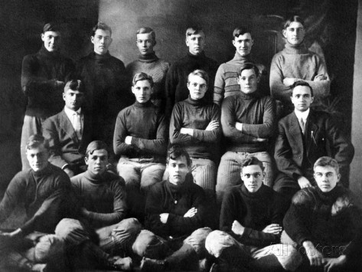
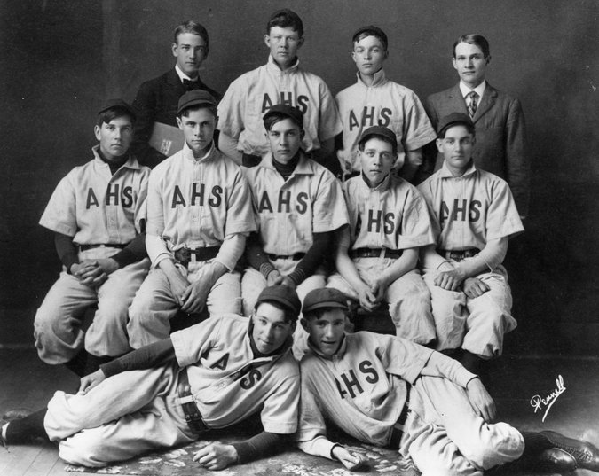
In Abilene, Dwight's 10-month-old brother Paul died of diphtheria when Dwight was 4 years old. Despite the tragedy, Dwight formed happy childhood memories in Abilene that he would cherish throughout his life. Among these were his days playing baseball and football at Abilene High School.
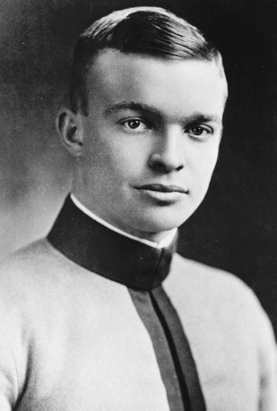
After Eisenhower graduated from high school in 1909, he joined his father and uncle at the Belle Springs Creamery while also moonlighting as a fireman. Eisenhower used the money he earned to pay his younger brother Edgar’s tuition at the University of Michigan. The brothers had a deal: After two years, they’d switch places—with Edgar then working to support Eisenhower's college education. Luckily for Edgar, he never had to live up to his end of the deal.
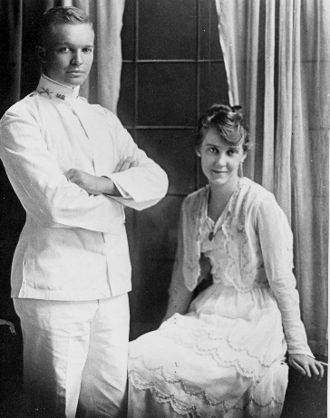
In 1911, Dwight landed an appointment at the United States Military Academy in West Point, New York, where attendance was free of charge. Once again he was a star on the football field, until a series of knee injuries forced him to stop playing. In 1915, Eisenhower proudly graduated from West Point, and was commissioned as a second lieutenant.
After graduation, Eisenhower was stationed in Texas, where he met and started dating 18-year-old Mamie Geneva Doud from Denver, Colorado. The couple married on July 1, 1916. Eisenhower was promoted to first lieutenant on his wedding day. For the first few years of Eisenhower's military career, he and Mamie moved from post to post throughout Texas, Georgia, Maryland, Pennsylvania and New Jersey. In 1917, Mamie gave birth to the couple's first son, Doud Dwight.

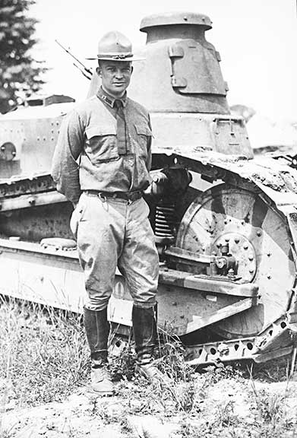
Military Career
In 1917 the United States entered WWI. Although Eisenhower hoped to be commissioned overseas, he was instead appointed to run a tank training center at Camp Colt in Gettysburg, Pennsylvania. Throughout the war and afterward, Eisenhower continued to rise through the ranks. By 1920, he was promoted to major, after having volunteered for the Tank Corps, in the War Department's first transcontinental motor convoy, the previous year.
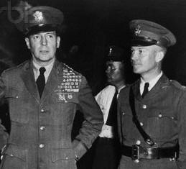
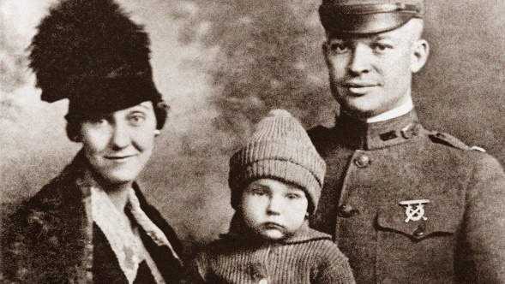
In 1921, tragedy struck at home, when the Eisenhower’s' firstborn son, Doud Dwight, died of scarlet fever at the age of 3. Mamie gave birth to a second son, John Sheldon Doud, in 1922. In 1924 Eisenhower applied to the Army's prestigious graduate school, the Command and General Staff School at Ft. Leavenworth, Kansas, and was accepted. He graduated first in his class of 245 in 1926, with a firm reputation for his military prowess.
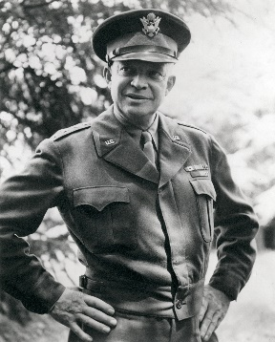
From 1927 to 1929 Eisenhower toured Europe for the War Department, under General John Pershing. After finishing his tour in 1929, Eisenhower was appointed chief military aide under General Douglas MacArthur. From 1935 to 1939 Eisenhower served under MacArthur as assistant military advisor to the Philippines. Eisenhower returned to the United States in early 1940.
In 1941 Eisenhower became chief of staff for the Third Army. Eisenhower was soon promoted to brigadier general for his leadership of the Louisiana Maneuvers. Late that year he was transferred to the War Plans division in Washington, D.C. In 1942, he was promoted to major general. Just months later, he became commander-in-chief of the Allied Forces.
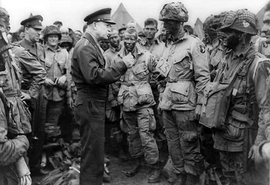
On D-Day, June 6, 1944, Eisenhower commanded the Allied forces in the Normandy invasion. In December of that year he was promoted to five-star rank. After Germany's surrender in 1945, he was made military governor of the U.S. Occupied Zone. Eisenhower then returned home to Abilene and received a hero's welcome. A few months later, he was appointed U.S. Army chief of staff. In 1948, he was elected president of Columbia University, a position he held until December of 1950, when he decided to leave Columbia to accept an appointment as first Supreme Allied Commander of the North Atlantic Treaty Organization. While in Paris with NATO, Eisenhower was encouraged by Republican emissaries to run for president of the United States.

