How the Bomb changed the World? Pbs.org/program/bomb
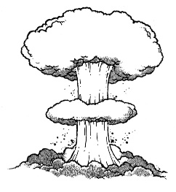
- In 1938, in Germany, a physicist discovers splitting the nucleus of the uranium atom. What is wrong with the timing?

  - As physicists around the world realize this, what is the fear?

- How do the scientists get the government to start making the bomb?

- How does the Bomb project get the name Manhattan project?

  - How many people contribute to the project?

- Who leads the program?

  - What has he been in charge of?

- Why is Oppenheimer picked to run the science portion of the project? Be specific.

- Why do they start using Plutonium?

- Where is the secret laboratory?

  - What is left there today?

- Of the 400 scientists at Los Alamos, how many were women?

- How do they keep the project secret?

- How did they fix the problem with the Plutonium bomb?

  - What are the Nazi scientists introducing?

  - The British sent physicist to help, including K. Fuchs, who is a dedicated what?

- What was Trinity?

