Korean War Notes
MacArthur |  | Achievements |  | Personality Traits
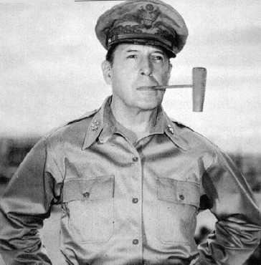
Phase 1 | Description
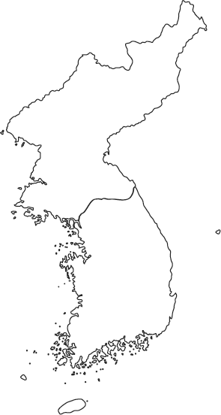
Phase 2 | Description |  | Decision #1 |  | Truman | MacArthur |  | Your Opinion
Phase 3 | Description
Phase 4 | Description |  | Decision #2 |  | Truman | MacArthur |  | Your Opinion
Phase 5 | Description

