Physical Map of Russia
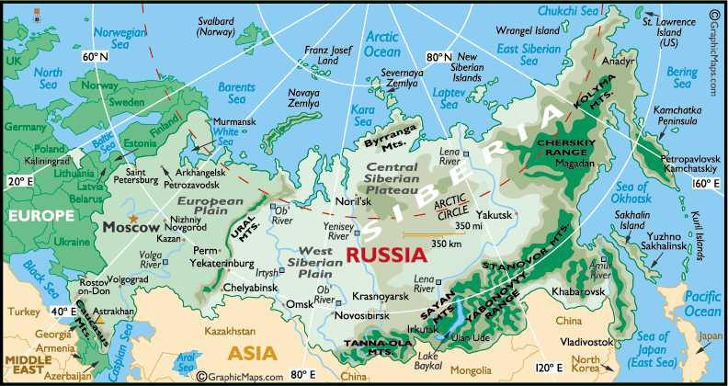
- Use this map to label #1-12 on your Map of Russia.
- Use this map to label the cities: Moscow, Saint Petersburg, Volgograd (Stalingrad), and Vladivostok

