United States Actions After WWII
(From the video: describe 5 turning points after WWII)
1
2
3
4
5

Cold War Speeches
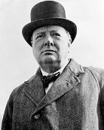  Winston Churchill  Prime Minister of Great Britain | 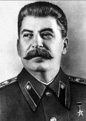  Joseph Stalin  Leader of U.S.S.R.
1.  2. a.  b.  c. | 1.  2. a.  b.  c.
NiIkolai Novikov  Soviet Ambassador to the U.S. | 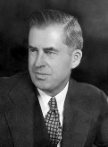  Henry Wallace  Former Vice President of U.S.
1.  2. a.  b.  c. | 1.  2. a.  b.  c.

