Treaties of Brest-Litovsk

Part 1: The Soviet Union Quits WWI
The road to Brest-Litovsk began with Lenin’s famous Decree on Peace, presented to the Congress of Soviets the day after the October 1917 revolution. This decree ordered the new government to “start immediate negotiations for peace” – though it also insisted any peace deal with Germany must not incur excessive costs or concessions for Russia. This condition was problematic because in late 1917 Germany was in a much stronger military position. German forces occupied all of Poland and Lithuania; some had pushed into the southern tip of the Ukraine, while others were poised to move deep into the Baltic States; St Petersburg itself was in striking distance of a German advance. The new leaders of Russia were in no position to dictate terms in any treaty negotiation – and were clear that any German peace delegation would demand the surrender of large amounts of Russian territory.

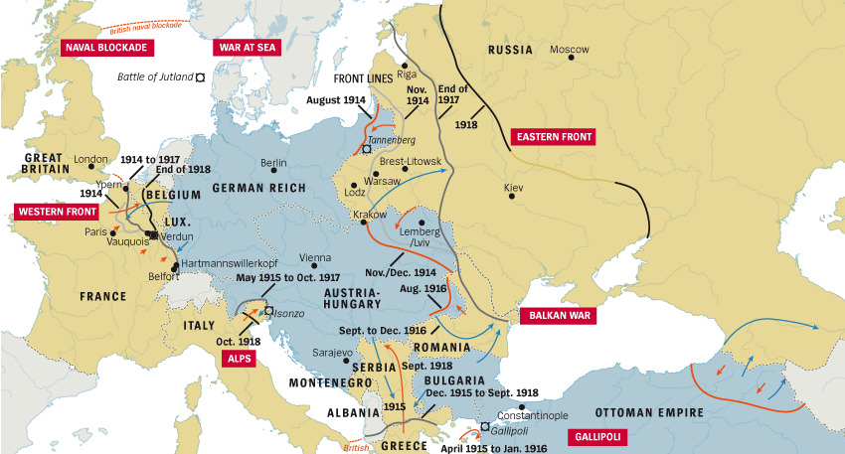

Part 2: The First Negotiations

In mid-December 1917 German and Russian delegates met at the Polish town of Brest-Litovsk and agreed to an indefinite ceasefire. Formal peace talks began five days later. Privately, the members of the German delegation loathed the Bolsheviks sent to negotiate on behalf of Russia. But the Germans, recognizing the inexperience of the Russian delegation, hid their contempt and instead cultivated an atmosphere of friendliness. They dined and socialized with the Bolshevik group, toasting their revolution and praising them for casting off the corrupt Tsar. As the Russians became more relaxed and confident they leaked information about the state of their government, their military and their nation.

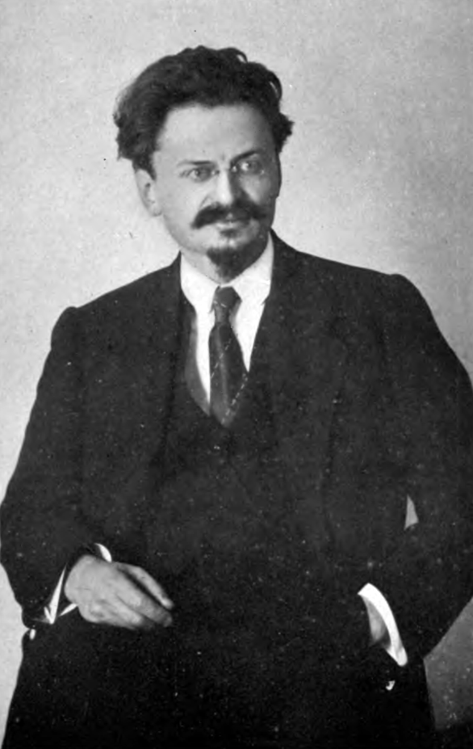
This friendliness ended a week later with the arrival of Leon Trotsky, the Soviet commissar for foreign affairs. Trotsky ordered an end to socializing and mixed dining, and demanded that all negotiations be done across the table. Trotsky behaved more like a victor than the vanquished. Several times Trotsky lectured the German delegation about the imminent socialist revolution in their own country. On one occasion he even produced socialist propaganda, printed in German, and distributed it to German soldiers. Trotsky believed a socialist revolution would erupt in Germany sometime in 1918. He demanded peace without concessions.

All this infuriated the Germans, who were impatient to end the war with Russia so they could redeploy their forces to the Western Front. Germany’s demands were initially quite modest, wanting only the independence of Poland and Lithuania. Trotsky, however, insisted on peace without concessions. He began to purposely stall the process while socialist agitators working within Germany itself attempted to incite and hasten revolution. Trotsky was belligerent and stubborn during discussion, arguing endlessly over minor points, threatening to quit the negotiations and continually calling for recesses. The Germans could not believe Trotsky’s tone, one general commenting that he ‘negotiated’ as though the Russians were winning the war rather than losing it. When the Germans presented another list of demands in January, Trotsky refused to sign and returned to Russia.

Part 3: Return to War

The Bolshevik party then entered a period of division over the terms of a treaty with Germany.

Lenin’s wish was for that the German proposal be signed immediately: to delay was to risk a German offensive that might overrun St Petersburg and crush the Soviet government.

Another faction, led by Nikolai Bukharin, rejected any suggestion of a peace treaty between the Soviets and a capitalist country; the war must be continued, Bukharin argued, to inspire German workers to take up arms against their own government.

Trotsky’s position was in the middle: he argued that German treaty ultimatums should be refused but did not believe Russia’s army or the Red Guards were capable of withstanding another German offensive.

These internal divisions continued until the mid-February 1918 when the German high command, frustrated at the lack of progress, suspended the armistice and ordered the bombardment of Petrograd and invaded the Baltic States, the Ukraine and Belarus. German troops continued to advance, at one point reaching the outskirts of Petrograd, forcing the Bolsheviks to relocate the capital to Moscow.

Part 4: The Treaty of Brest-Litovsk

The German offensive forced the Bolsheviks back to the negotiating table in late February. This time the German delegates issued the Russians with an ultimatum: they had a five-day timeline to discuss and sign the treaty. Under the terms of this new agreement:

- Poland, Finland, the Baltic States and most of the Ukraine would be surrendered to Germany.
- Russia would lose 1.3 million square miles of important territory, including important grain-growing regions in the Ukraine.
- It would surrender 62 million people to German rule, or around one-third of its total population.
- It would also lose 28 percent of its heavy industries and three-quarters of its iron and coal reserves.
- Russia agreed to pay six billion marks in compensation to German interests for their losses.

Lenin threatened to resign as party leader if the treaty was not accepted. The Congress, however, was relieved to be free of the war and the threat to its government, so voted to accept and endorse the treat. But the harsh territorial and economic terms imposed by Brest-Litovsk would soon be felt by the Bolshevik government, as it entered a fight for survival.

By any measure the Brest-Litovsk agreement offered humiliating terms: it treated Soviet Russia as a defeated nation and Germany as a conquering power, entitled to the spoils of war.
With the Soviet regime at risk of defeat, Bolsheviks negotiators signed the Treaty of Brest-Litovsk on March 3rd 1918.

Lenin had got his own way by arguing that any losses to Germany – a nation on the “doorstep of socialist revolution” – would be temporary; He believed that Germany would lose WWI and any treaties or annexations would soon be null and void.

Treaty of Brest-Litovsk Map
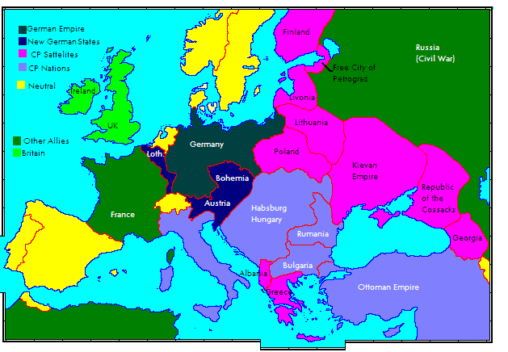

Part 5: The Treaty of Versailles

Soviet Russia was naturally excluded from the Paris peace talks. The formal reason was because it had already negotiated a separate peace with Germany. In the Treaty of Brest-Litovsk (March 1918) Germany had taken away a third of Russia's population, one half of Russia's industrial undertakings and nine-tenths of Russia's coalmines, coupled with an indemnity of six billion marks. But although physically absent, Russia’s presence made itself felt in all the deliberations at the Peace Conference.
The real reason for the exclusion of Russia was that all the imperialist powers were the sworn enemies of Bolshevism, which they correctly saw as the most dangerous threat to their interests. Even while the Great Powers sat around the negotiating table, fighting over the map of the world like dogs fighting over a bone, the flames of revolution were spreading to Germany, a soviet republic had been declared in Hungary and also Bavaria, and Trotsky’s Red Army was beating back the counterrevolutionary White forces. British, American, Japanese and French forces were intervening actively on the side of the Whites in an anti-Bolshevik crusade.
This explains the speed with which the German ruling class agreed to the Allies terms. However, they hoped that a reasonable deal could be reached. After all, the Kaiser was gone and Germany now had a democratic government.

In 1919 Lenin was still hoping that Soviet revolution in Vienna would support Soviet Hungary. All his hopes were placed on a revolution in Germany. Lenin wrote:
“The Soviet revolution in Germany will strengthen the international Soviet movement, which is the strongest argument against the Treaty of Versailles and against international imperialism in general.”
“It goes without saying that we regarded the Treaty of Versailles as an act of imperialist plunder, like the even more vicious Treaty of Brest Litovsk. But they understood that the imperialists (especially the French) were looking for an excuse to invade Germany, which would have been a setback for the revolution.”

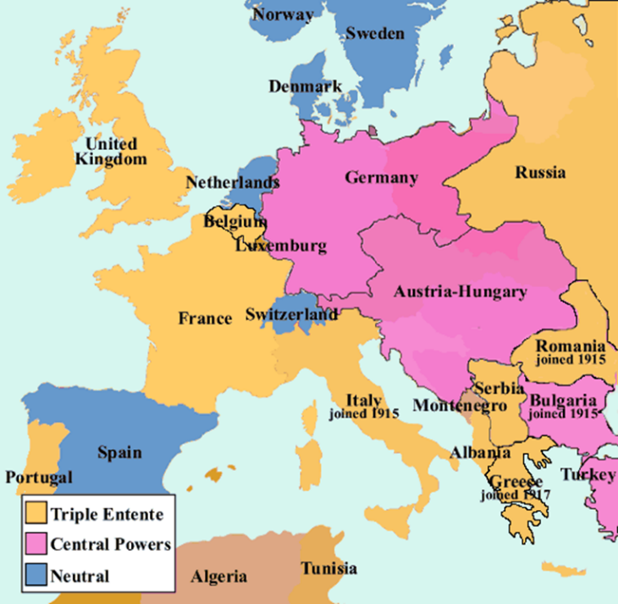
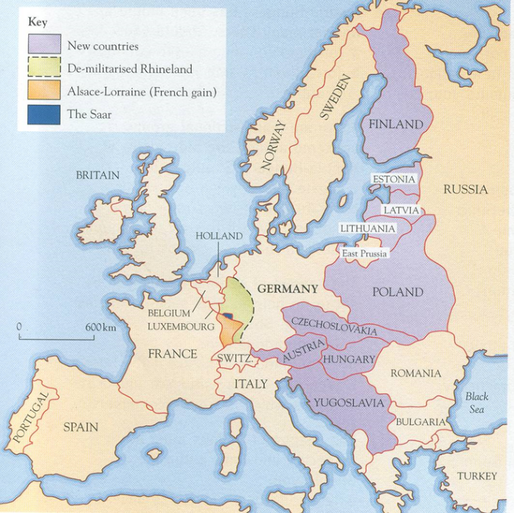
Pre WWI Europe
Post WWI Europe

